

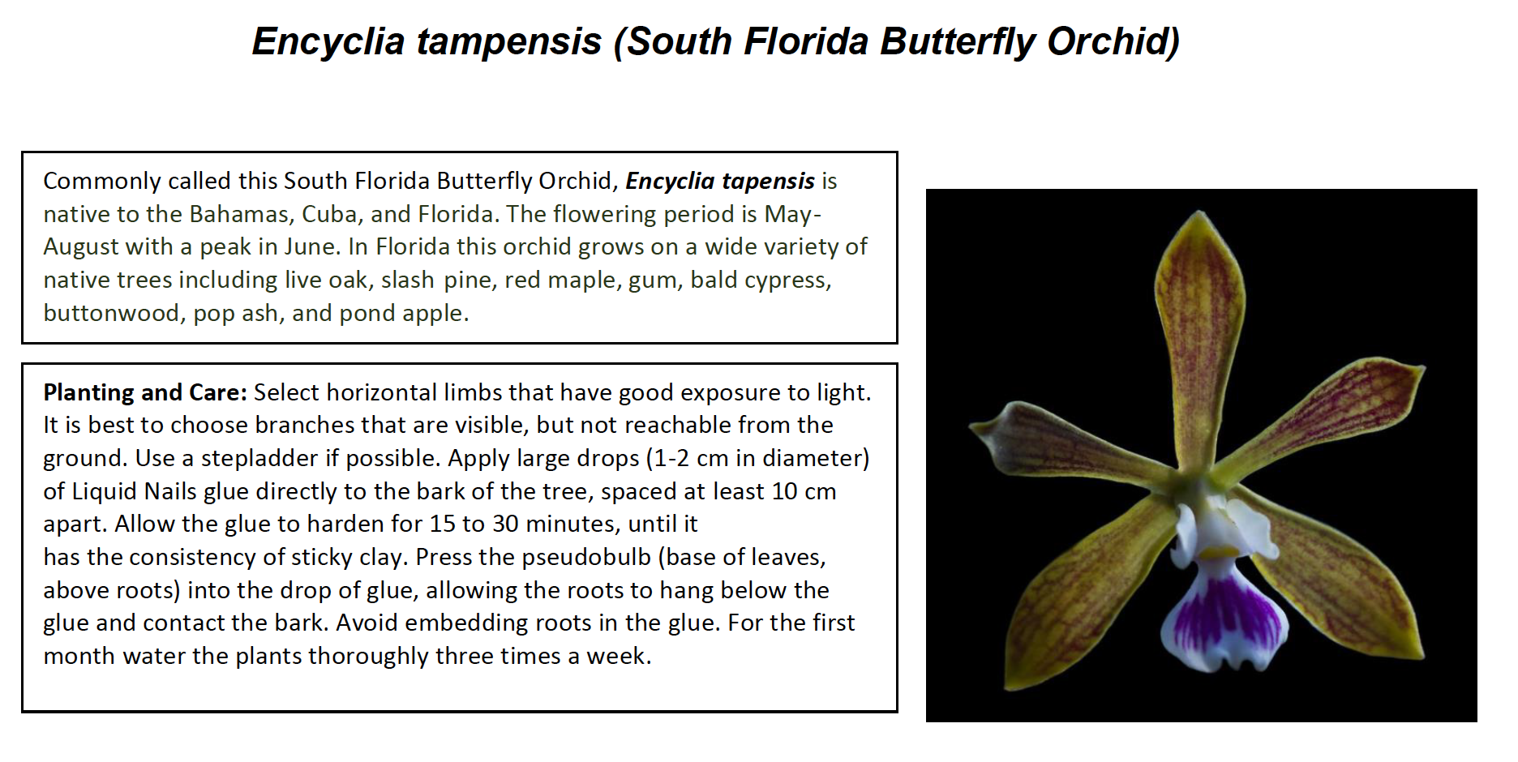



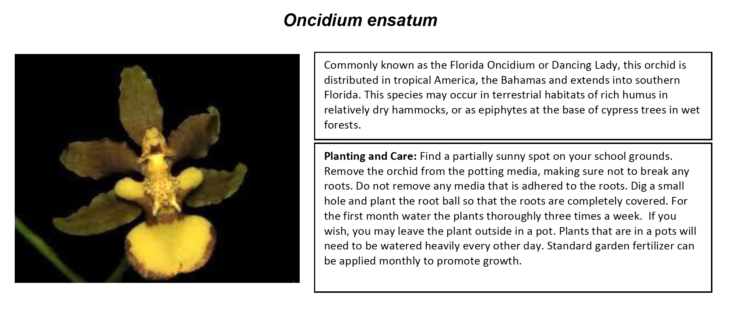

**Epidendrum amphistomum**

**As with most epidendrums, full sun is detrimental to their care. These enjoy bright shade, or sunlight made dapple by the canopy of trees. Mounting may be a great option by starting them horizontally. Once attached, place them in a wood or plastic basket adding large sized potting mix for orchids. Add some time release twice a year and water with rainwater as much as possible. Tap water holds many dissolved salts that make most young plants stress with excess salt buildups. Black or yellow leaf tips are an indicator of too many minerals in the water. A good downpour now and then will help rinse those salts build up in the media. A $5 bucket and lid from the box stores is one way to store some rainwater for later use.**

**Fertilizing is encouraged at a teaspoon per gallon strength given once a week. When done prior to a rainstorm, or afterwards, helps the absorption of the nutrients. Avoid chemical only applications to excessively dry plants.**

**The bloom for this Florida Native is spectacular. A round ball of flowers make up the inflorescence that emerges in the spring. It is fragrant and can eventually be naturalized in most South Florida homes. It can tolerate the brief days of winter that occur from time to time without worry, once established.**

**Prosthecia Cochleata var. triandra**

**Called the Clamshell Orchids, this variety from Florida is earning its’ own distinction from the more popular and commercially available variety found in the Caribbean, Mexico and most Northern Latin America. What is setting it apart is its three anther caps, versus the two found in the more common type. Differences aside these can be grown the same.**

**In Florida they grow on trees although in much brighter conditions than the Epidendrum. Think of it as the edge of the forest and the bright light that an open landscape offers, versus Epidendrum that would be more within the forest hammocks of South Florida. These like the nooks of branches that allow light, air and rain if you desire to attach them to your trees. Remember that a horizontal limb takes less effort for an orchid to grow on than a vertical orientation.**

**The aforementioned fertilizing and water conditions apply for a plant newly introduced to your home or landscape. It is important to nourish and water them on a weekly basis and allowing the natural rain patterns to take over for you.**

**These can be grown in Cattleya conditions. Some have potted them in lava rock. A shallow basket is ideal as too much potting material can remain moist for longer than roots can tolerate. Allow the plant to dry completely from time to time and in times of drought, after days of windy hot air, it may need no more than three waterings per week. During winter, cold, or overcast days it is best to restrain on the water as drying times will take longer.**